
Contents
What is a Fellow in Palliative Care Nursing (FPCN®) 2
Application Checklist 2
HPNA Membership Requirements 2
Letters of Support 2
Essays which include evidence of significant contributions 2
Templated Curriculum Vitae (CV) 3
Applicant Bio 3
Applicant Headshot 3
Application Fee 3
Committee, Task Force, and Volunteer Participation 4
HPNA 4
HPCC 5
HPNF 5
Online Application Tips 6
Logging into Application Site 6
Beginning the application 6
CV Template 7
Letters of Support 7
Scoring Rubric 8
CV Rubric 8
Essay Response Rubric 9

What is a Fellow in Palliative Care Nursing (FPCN®)
A Fellow in Palliative Care Nursing (FPCN) designation represents a prestigious recognition of exceptional expertise, leadership, and commitment to advancing the field of palliative and hospice nursing. It signifies a profound dedication to providing comfort, dignity, and holistic care for individuals and families facing serious illnesses while fostering mentorship, interdisciplinary collaboration, and professional growth. Recipients of this distinction stand out in their contributions, whether through clinical excellence, research, education, advocacy, or service to organizations such as HPNA, HPCC, or HPNF. This honor not only acknowledges their achievements but also carries an expectation of continued leadership, mentorship, and innovation to further enhance the field of palliative care nursing and ongoing commitment to the mission of HPNA, HPCC and HPNF.

Application Checklist

HPNA Membership Requirements
☐ Applicant must be a current member of the Hospice and Palliative Nurses Association (HPNA) with evidence of continuous membership for at least five years (no lapse exceeding 60 days and no more than 1 lapse in membership during this 5-year period, regardless of the length of the lapse) and active participation in the Association over the past five (5) years.
☐ Applicant must be a Licensed Registered Nurse.
☐ HPNA Membership must be maintained to keep Fellow status.

Letters of Support
☐ Application requires two letters of support from professional peers.
☐ Professional peers should be chosen who know the applicant’s work well enough to verify and provide examples of the applicant’s strengths, contributions, and impact on the field of palliative care and/or nursing.
☐ Professional peers writing letters of support should state how long they have known the applicant, and in what capacity.
☐ At least one letter of support must be authored by an HPNA member.
☐ Letters of support must be submitted as attachments, preferably on official letterhead, signed by the author, and include the professional peer’s contact information.
☐ Professional Peers who will be submitting recommendations for a FPCN applicant may only submit up to two recommendations (2 FPCN applicants) for each application year cycle.
☐ Professional peers will submit their letter of support directly to info@hpna.org by 11:59 PM EST on June 1, 2026.

Essays which include evidence of significant contributions
☐ Describe the volunteer or leadership experiences/contributions you have undertaken with HPNA, HPCC, and/or HPNF. How did this experience contribute to the advancement of the organization’s mission, and in what ways did it challenge you to grow as a leader or professional? (600 words max)
☐ Share a specific example of your work in the hospice and/or palliative nursing field. How have your efforts made a meaningful impact on patients, families, or the community, and how do you see these contributions advancing the field as a whole? (400 words max)
☐ What will be your future engagement with HPNA, HPCC and/or HPNF to advance the field of hospice and palliative care and/or nursing? (200 words max)

Templated Curriculum Vitae (CV)
☐ Applicant must provide a CV (Curriculum Vitae) using the template provided in the application.

Applicant Bio
☐ Applicants must provide a brief bio (200 words or less).

Applicant Headshot
☐ High quality headshot of applicant submitted. This headshot is not used during review scoring. It will be used for marketing purposes if/when the applicant is awarded designation.

Application Fee
☐ An application fee of $250 is required. If an applicant is not accepted for induction, the fee will remain as credit towards a future application. No refunds will be given. To process your application fee by credit card, please call 412-787-9301 option 1.

Committee, Task Force, and Volunteer Participation
To inquire whether your services not listed below may be included in the application and templated CV, please contact info@hpna.org.

HPNA
- Governance Committee
- Fellows Engagement and Selection Committee
- Membership Engagement Committee
- Palliative Nursing Summit Steering Committee
- HPNA Leadership Development Task Force
- Foley Scholar Grant Review Committee
- Summit Pain & Symptom Management Workgroup
- Summit Advance Care Planning Workgroup
- Summit Transitions of Care Workgroup
- Enterprise-Wide Pediatric Task Force
- Annual Assembly Planning Committee
- Clinical Practice Forum Planning Committee
- Team Conference for Hospice and Palliative Care Planning Committee
- Abstract Review for Annual Assembly and Clinical Practice Forum
- ACHPN Certification Review Faculty
- CHPN Certification Review Faculty
- HPNA Self-Assessment Exam Review Committee
- HPNA Award Selection Committee
- Advocacy Advisory Council/Committee
- HPNA State Ambassadors
- APN Advisory Council
- RN Advisory Council
- Research Advisory Council/Committee
- HPNA Chapter Board (regular chapter member does not apply)
- HPNA State Community Task Force
- HPNA State Community Committee
- Diversity, Equity, Inclusion, and Belonging Taskforce
- Diversity, Equity, Inclusion, and Belonging Committee
- Chair/Co-Chair of SIGS
- Education Review Committee

HPCC
- Exam Development Committees
ACHPN Exam Development Committee
APHSW-C Exam Development Committee
CHPN Exam Development Committee
CHPNA Exam Development Committee
CHPPN Exam Development Committee
CPLC Exam Development Committee
- Role Delineation Study Task Force
- Cut Score Task Force
- HPCC Awards Selection Committee
- Situational Judgement Exercise Development Committee
- Diversity, Equity, Inclusion, and Belonging Taskforce
- Diversity, Equity, Inclusion, and Belonging Committee

HPNF
- Certification Research Grant Review Committee
- Certification Scholarship Review Committee
- Chapter Education Grant Review Committee
- Conference Scholarship Review Committee
- Corporate Partnership Committee
- Education Scholarship Review Committee
- Florence Wald Fellows Committee
- Lentz Scholarship Review Committee
- PDIA Review Committee
- HPNF Award Selection Committee

Online Application Tips

Logging into Application Site
- Click on this link to be taken to the online application.
- Sign in using your HPNA username and password.
- Once logged in, click the green “apply” button.
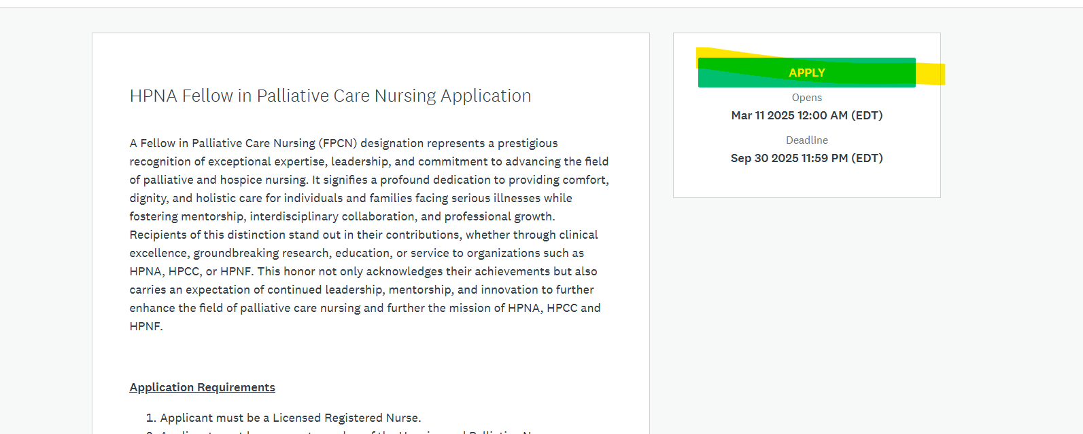

Beginning the application
- You will see the application overview page, which indicates the different tasks you’ll need to complete. Click through each section to see the requirements.

- The application is downloadable to print for note taking and organizing your information before inserting into the online application. Please note, only applications submitted via the online application platform will be accepted, no paper forms will be accepted for review.
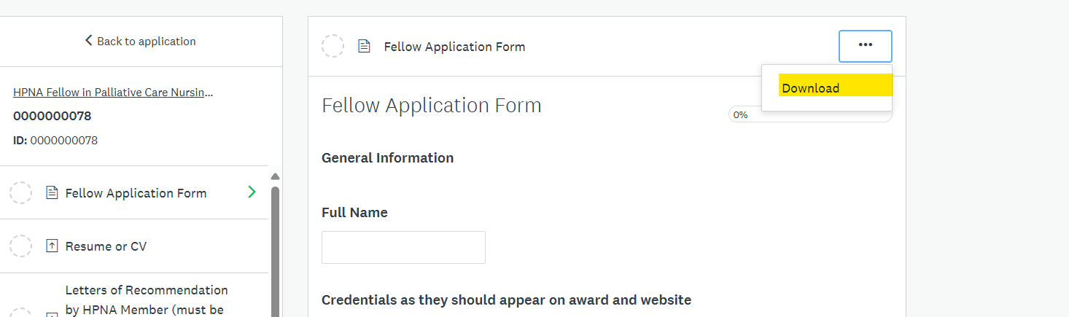

- As you complete each task, you’ll notice a green check mark next to the name of the task.
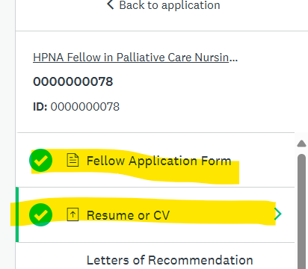
- After all tasks have been completed, click the “review” button to review the application in its entirety.
- When you’re ready, click the green “submit” button.


Please note: You can save your progress and come back to the application at any time! Your application does not need to be completed and submitted in one sitting. Once your application is submitted, you cannot go back in to edit your information.

CV Template
Applicant must use the following template
Applicants are required to use the provided CV template when submitting their application. This template is specifically designed to highlight involvement with HPNA, HPNF, and/or HPCC as a priority, followed by a traditional format to showcase professional experiences, qualifications, and expertise in hospice and palliative care. Note, rows can be added to each table.

Letters of Support
Application requires two letters of support from professional peers; letters must be received by the deadline. (At least one letter of support must be authored by an HPNA member). Professional peers should be chosen who know the applicant’s work well enough to verify and provide examples of the applicant’s strengths, contributions, and impact on the field of palliative care and/or nursing. Those writing letters of support should state how long they have known the applicant, and in what capacity. Letter of support should be sent as attachments, preferably on letterhead with signature. Professional Peers who will be submitting letters of support for a FPCN applicant may only submit up to two letters of support (2 FPCN applicants) for each application year cycle. Letters of Support must be submitted by the supporter to info@hpna.org by 11:59 PM EST on JUNE 1, 2026.
It is the responsibility of the applicant to ensure that the letters of support are submitted by the deadline.

Scoring Rubric
The review committee will evaluate applications using the following scoring rubric, which has been provided to applicants for transparency in how points will be awarded. This rubric outlines specific criteria and corresponding point values to ensure a fair and consistent assessment process. Applicants are encouraged to review the rubric carefully to understand how their qualifications, involvement with HPNA, HPNF, and/or HPCC, and professional accomplishments in hospice and palliative care will be scored.

CV Rubric – 100 Points Possible for CV rubric. It is anticipated that applicants would need points in both sections (Service and Engagement with HPNA, HPCC, and/or HPNF Criteria and Professional Background & Impact on Hospice and Palliative Care Criteria), but a score of 50 between both sections) would be considered acceptable.

Service and Engagement with HPNA, HPCC, and/or HPNF Criteria | Does not meet expectations | Nearly meets expectations | Meets expectations
Board, Committee, and/or Taskforce Participation | Minimal or no involvement.  0 Points | Consistent participation with some leadership roles. 1-9 points | Multiple leadership roles (chair, co-chair, elected position) with significant impact.  10 Points
HPNA Publications and Publication Activities | No publications or engagement in this area.  0 Points | Some publications or involvement in publication activities.  1-9 points | Multiple publications in HPNA-affiliated journals/books and significant editorial/review roles.  10 Points
Awards from HPNA, HPCC, and/or HPNF | No awards.  0 Points | Nomination or minor recognition.  1-9 points | At least one significant award.  10 Points
HPCC Certification | No certification.  0 Points |  | Holds at least one HPCC certification.  10 Points
Conferences, Educational Events, and Volunteer Activities | Minimal or no involvement.  0 Points | Moderate involvement in events and volunteer roles.  1-9 points | Consistent, impactful roles such as speaker, planning team, and volunteer leader.  10 Points

Professional Background & Impact on Hospice and Palliative Care Criteria | Does not meet expectations | Nearly meets expectations | Meets expectations
Education & Post Degree Training | No advanced education in relevant fields.  0 Points | Limited formal education in palliative care.  1-4 | Advanced degree(s) with specialized palliative care training.  5 Points
Employment & Appointments | Minimal or no experience.  0 Points | Steady work in hospice/palliative care with some leadership.  1-4 | Multiple leadership roles in academic, clinical, or policy settings.  5 Points
Consulting & Grant Support | No experience.  0 Points | Moderate consulting and research involvement.  1-4 | Significant consulting roles and multiple funded grants.  5 Points
Presentations & Publications Beyond HPNA | No presentations or publications.  0 Points | Some presentations and publications.  1-9 | Frequent national/international invited presentations and high-impact publications.  10 Points
Professional Memberships & Committee Involvement | No memberships.  0 Points | Consistent membership with occasional leadership.  1-9 | Active in multiple professional societies with leadership roles.  10 Points
Community & Professional Service Outreach | No outreach activities.  0 Points | Moderate involvement.  1-4 | Leadership in multiple service initiatives at all levels.  5 Points
Teaching, Mentoring, & Precepting Activities | No involvement.  0 Points | Consistent involvement in at least one area.  1-9 | Extensive experience in teaching, mentoring, and/or precepting at multiple levels.  10 Points

Essay Response Rubric – 100 Points Possible.
Criteria  (30 Points Possible) | Does not meet expectations | Nearly meets expectations | Meets expectations
Section 1: Activities in support of service to HPNA, HPCC, and/or HPNF  Describe how your experiences with HPNA, HPCC, and/or HPNF have a) contributed to the advancement of the organization’s mission. Include how did these experiences challenge you to grow as a leader and/or professional. | Candidate’s exemplar is not clearly connected to the organization’s mission.  0 Points | Candidate clearly and concisely articulates one clear example of how their experience connects to the organization’s mission  1-14 Points | Candidate clearly and concisely articulates at least two clear examples of how their experience connects to the organization’s mission.  15 Points
 | Candidate’s examples of how their experience challenged them to grow as a leader and/or professional are convoluted.  0 Points | Candidate clearly and concisely articulates one clear example of how their experience challenged them to grow as a leader and/or professional.  1-14 | Candidate clearly and concisely articulates at least two clear examples of how their experience challenged them to grow as a leader and/or professional.  15 Points

Criteria  (30 Points Possible) | Does not meet expectations | Nearly meets expectations | Meets expectations
Section 2: Activities in support of or service to the field of hospice and palliative care and/or nursing  Describe how your unique contributions in patient care, education, research, and/or advocacy have impacted the field of hospice and palliative care and/or nursing | Candidate’s description of their contributions to the field of hospice and palliative care and/or nursing is not clearly articulated.  0 Points | Candidate clearly and concisely articulates at least one contribution in the field of hospice and palliative care and/or nursing.  1-14 | Candidate clearly and concisely articulates at least two contributions in the field of hospice and palliative care and/or nursing.  15 Points
 | Candidate does not adequately describe how their contributions have impacted the field of hospice and palliative care and/or nursing.  0 Points | Candidate clearly and concisely articulates at this contribution has impacted the field of hospice and palliative care and/or nursing  1-14 | Candidate clearly and concisely articulates at how these contributions have impacted the field of hospice and palliative care and/or nursing.  15 Points

Criteria  (20 Points Possible) | Does not meet expectations | Nearly meets expectations | Meets expectations
Section 3: Future Engagement  Describe how your future engagement with HPNA, HPCC, and/or HPNF will advance the field of hospice and palliative nursing and/or care. | Candidate’s description of how their future engagement with HPNA, HPCC, and/or HPNF will advance the field of hospice and palliative care and/or nursing is not clearly articulated  0 Points | Candidate clearly and concisely articulates at least one example of how their future engagement with HPNA, HPCC, and/or HPNF will advance the field of hospice and palliative care and/or nursing.  1-19 Points | Candidate clearly and concisely articulates at least two examples of how their future engagement with HPNA, HPCC, and/or HPNF will advance the field of hospice and palliative care and/or nursing.  20 Points

Criteria  (20 Points Possible) | Does not meet expectations | Nearly meets expectations | Meets expectations
Organization and structure (10 points possible) | Candidate’s writing has limited evidence of structure and/or organization. Ideas are not fully developed. Minimal use of transitions noted.  Goes over word count.  0 Points | Candidate’s writing demonstrates logical organization, but some ideas are not fully or consistently developed. Transitions are awkward at times but the flow is adequately maintained.  Stays within word count.  1-9 | Candidate’s writing demonstrates logical and subtle sequencing of ideas through well-developed paragraphs; transitions are used to enhance organization.  Stays within word count.  10 Points
Mechanics/usage (10 points possible) | Numerous errors in punctuation, capitalization, spelling, sentence structure, or word usage with significant impact on the content of the essay.  0 Points | Few errors in punctuation, capitalization, spelling, sentence structure, or word usage with minimal impact on the content of the essay.  1-9 | No errors in punctuation, capitalization, or spelling. No errors in sentence structure or word usage.  10 Points

